Mini Project
Task: Eid Greeting Card
- Design of card on graph sheet
- Flow of program
- Numbering of program
- Flowchart
- Logic Building
- Program with labeling
- Output

1. Design of Card on Graph Sheet

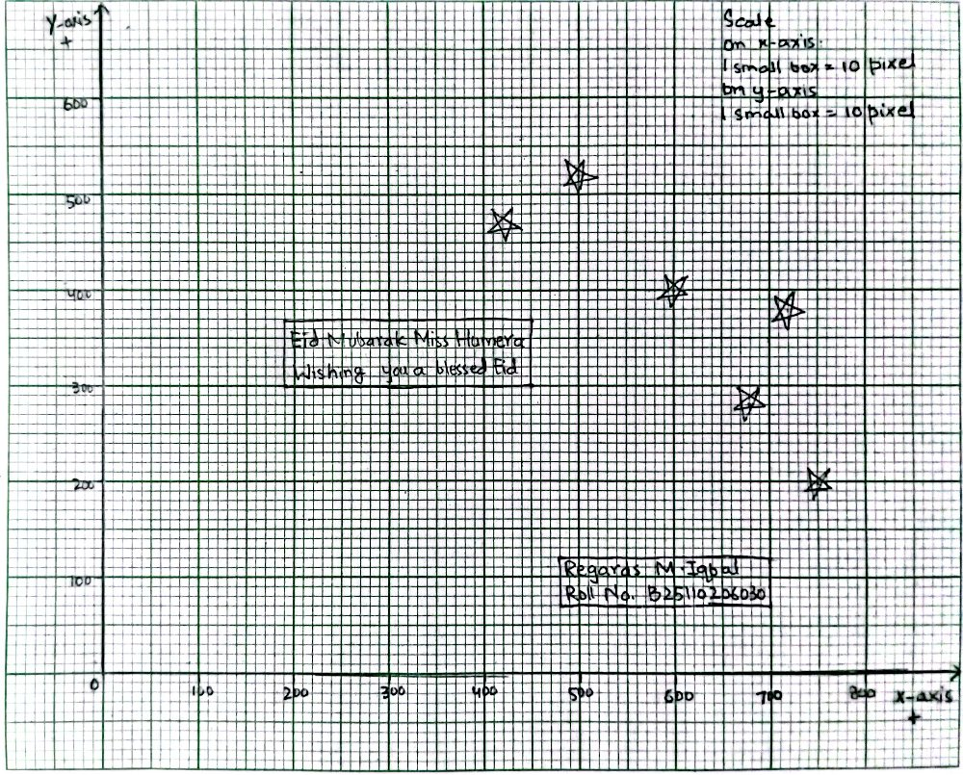

2. Flow of Program
- Initialization: The program imports necessary libraries (OpenGL, Windows Multimedia, RGBA) and defines the global window dimensions (800x600).
- Window Creation: The main() function initializes GLUT, sets the display mode to RGB, and creates the application window.
- Environment Setup: The myInit() function configures a 2D orthographic projection matrix so that OpenGL coordinates match standard pixel coordinates.
- Asset Loading: Within myInit(), the 24-bit .bmp background image is loaded into memory, and the .wav audio file is triggered to play asynchronously on a loop.
- Render Trigger: glutDisplayFunc() calls the display() function to begin rendering graphics.
- Layer 1 (Background): The screen buffer is cleared, the raster position is set to the origin (0,0), and the image pixel data is drawn to the screen.
- Layer 2 (Geometry): The drawStar() function is called multiple times, executing trigonometric loops to draw GL_POLYGON stars at specific coordinates.
- Layer 3 (Typography): The renderText() function iterates through character arrays, rendering the greeting and student details using GLUT bitmap fonts.
- Execution: glFlush() forces the rendered layers to the screen, and the program enters glutMainLoop().

3. Flowchart
[ Start Program ]
|
v
[ Initialize GLUT & Create 800x600 Window ]
|
v
[ Execute myInit() Function ]
|-- Set gluOrtho2D(0, 800, 0, 600)
|-- Load "eid_bg.bmp" via RGBApixmap
|-- Trigger PlaySound() on separate thread
v
[ Enter glutMainLoop() & Call display() ]
|
v
[ Clear GL_COLOR_BUFFER_BIT ]
|
v
[ Draw BMP Background at Origin (0,0) ]
|
v
[ Generate GL_POLYGON Stars via Trigonometry ]
|
v
[ Render Bitmap Fonts for Greetings & Details ]
|
v
[ Flush Buffer to Screen (glFlush) ]

4. Logic Building
- Coordinate System Logic: By using gluOrtho2D(0, screenWidth, 0, screenHeight), the program maps the OpenGL coordinate system to a precise 1:1 pixel grid. This makes placing UI elements, like text and stars, mathematically straightforward rather than relying on normalized device coordinates (-1.0 to 1.0).
- Geometric Generation (The Stars): Instead of using static images for stars, the drawStar function logically generates them dynamically. It uses a for loop with 10 iterations, calculating vertices using sin() and cos(). By alternating between a large outer radius and a smaller inner radius using the modulo operator (i % 2 == 0), it creates the sharp points of a star within a single GL_POLYGON.
- Asset Management: The custom RGBA.h library is utilized to bypass complex OpenGL texture wrapping and filtering. It logically parses the uncompressed raw pixel data of a 24-bit BMP file and blits it directly to the frame buffer.
- Audio Multithreading: The logic behind the audio relies on the SND_ASYNC flag in the Windows API. This ensures the audio executes on a background thread, preventing the PlaySound function from blocking the main OpenGL rendering loop.
5. Program with Labeling and Numbering
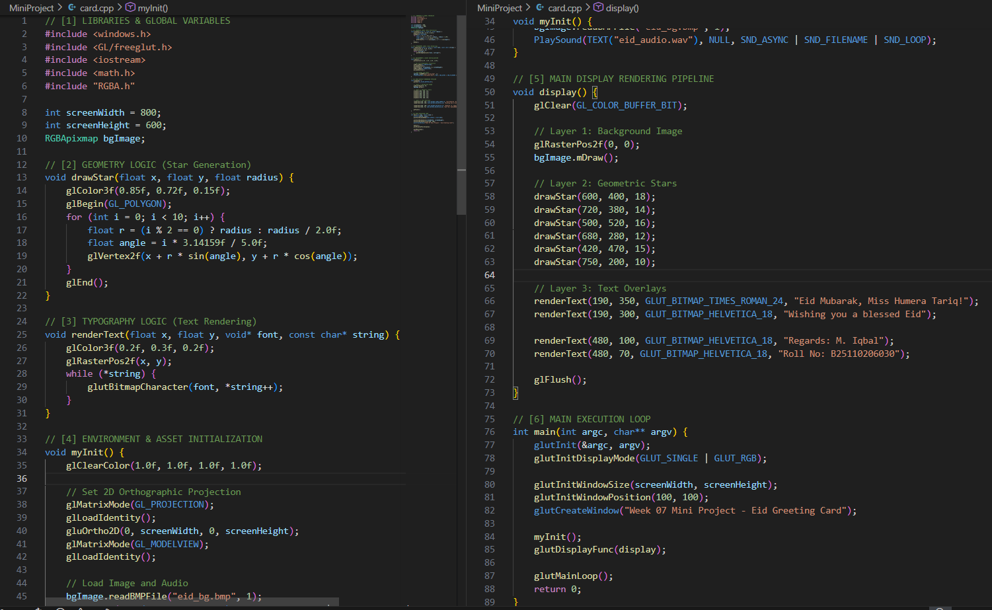

6. Output:
